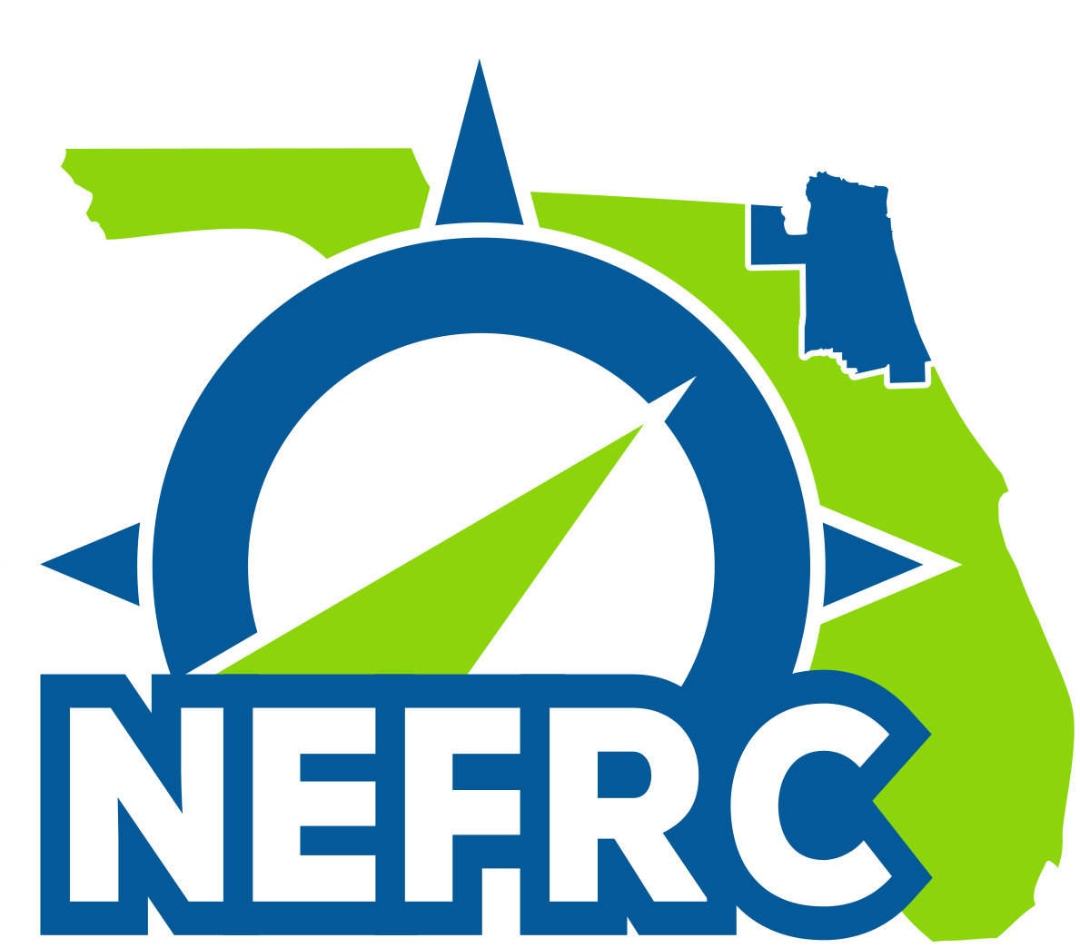 | Northeast Florida  Local Emergency  Planning Committee  Wednesday, February 13, 2019  10:00 a.m. | 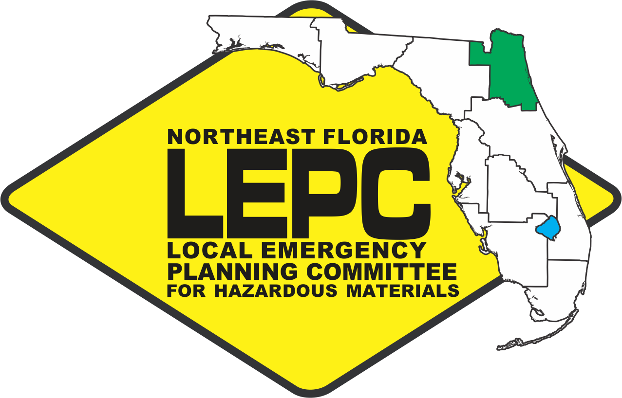

M I N U T E S

A meeting of the Northeast Florida Local Emergency Planning Committee was held on Wednesday, February 13, 2019, at 10:05 a.m., at the Northeast Florida Regional Council, 100 Festival Park Avenue, Jacksonville, Florida 32202. Chairperson Richard Knoff called the meeting to order with the following members:

Present

Anthony Cinelli – Local Environmental
Sandi Courson – Health
George Faucher, Jr. – Firefighting
Helen Gainey for Terry Carr – Environmental
Ben Huron – Local Environmental
Gracie Kennedy – Environmental
Chris Knaff for Chief Joel Sneed – Firefighting
Chief Richard Knoff – Firefighting
Brooke Martin – Transportation
Brian Peterson for Chief Todd Smith – Firefighting
Amy Pilgrim for Henry Bonar – Facility Owner
Fred Rogers – Emergency Management
Chief John Scott, III - Firefighting
Chief Harvey Silcox – Firefighting
Roger Studenski – Transportation

Absent

Douglas Coleman – Environmental
Paul Crist - Transportation
Chief Lenny Ensalaco – Firefighting
Bek Harrison – Law Enforcement
Chief Joe King - Firefighting
Michael Laycock – Facility Operator
Quin Romay – Emergency Management
John Ward – Emergency Management

Excused
John Coffey - Health
Bill Decker – Local Environmental
Michael Lesser – Facility Operator
William Lord – Facility Owner
Steve Millican – Emergency Management

Guests: Jonathan Lord (via phone), Dan Deptula (EPD-COJ), Brian Peterson (EPD-COJ), Bill Raspet (NASJax), Katie Von (UF Health Jax), David Henry (UF Health Jax) Gina Lambert (FDEM), Alex Sease (Contanda Terminals), Matt Currie (DHS), Bing Crosby (DHS), Molly Keyser (USCG), and other members of the public.

Staff Present: Tyler Nolen and Sheron Forde

*Approval of Minutes

As there was not a quorum at the November meeting, the August minutes need to be voted on.

Chair Knoff called for a motion on the August 2018 Meeting Minutes. Mr. Scott made the motion to approve the August 2018 Minutes; seconded by Chief Silcox. Motion carried.

Chair Knoff called for a motion on the November 2018 Meeting Summary Minutes. Chief Silcox made the motion to approve the November 2018 Minutes; seconded by Mr. Scott. Motion carried.

State Emergency Response Commission (SERC) Meetings

Mr. Nolen provided an overview of the Training Task Force, LEPC Chair/Coordinator, and SERC meetings that were held in conjunction with the HazMat Symposium January 22-23, 2019 in Daytona Beach, FL.

Training Task Force Meeting
During the Training Task Force meeting, discussion was primarily on the recently released HazMat Medical protocols, which includes K-9 safety protocols. First responders are being asked to review and implement plans that is workable for them. A copy of the protocols can be obtained from staff should anyone want one.

LEPC Chairs
The LEPC meeting included discussions on the hazard analysis working group’s consideration of standardizing site plans with certain criteria for facilities. However, they are concerned that the implementation may be difficult. Members were asked to provide staff with any suggestions they may have for consideration by the working group.

HazMat Team Assessments are continuing towards completion. JFRD was completed for this year, with St. Johns and Clay County’s scheduled for completion by the end of this calendar year.

New contracts have been received and is now a fixed fee, which provides for reimbursement after completion of tasks.

SERC Meetings
This meeting was primarily a review of the above meetings. Additionally, the Yatabe Awards were presented at this meeting.

Current Business/Reports

Staff announced that the Northeast Florida Regional Council’s Chief Executive Officer, Brian Teeple, who has served the Council for 33+ years, will be retiring effective February 28, 2019. Ms. Elizabeth Payne will be taking over as the new Chief Executive Officer on March 1, 2019.

Hazardous Material Release Report
Mr. Nolen provided an overview of Section 304 Release Investigations, as well as traffic evacuations, injuries or deaths from HazMat incidents.

LEPC Contract
An overview of the LEPC contract was provided, including the status of each tasks. It was stated that Task 7, HazMat Exercise, is still not yet completed as the State’s requirement was not met. However, this task is expected will be completed in May 2019 with the Georgia Pacific exercise. Additionally, Task 4 – Public Availability of Information and Task 5 – LEPC Hazardous Materials Response Plan are the other remaining items to be completed. These are slated to be completed in June 2019.

Award Winners
Mr. Eric Anderson was recognized as this year’s Yatabe Award recipient for his efforts with the LEPC. A Certificate of Appreciation was awarded to Mr. Michael Lesser for his dedication and role in the LEPC. Chair Knoff shared his appreciation for Mr. Anderson’s efforts with the LEPC.

Hazardous Materials Symposium
Mr. Nolen stated that in this the seventh year of the symposium and sixth year of the competition there were 447 students, 82 instructors, 41 staff members and 30 sponsors with over 40 vendors. Three counties from Northeast Florida took part in the competition: Clay, Duval and St. Johns Counties. Additionally, this was the first time the event was live streamed.

The symposium continues to grow, with 13 states and one international attendees. The Northeast Florida LEPC sent 57 participants to the symposium. It has been announced that Chair Knoff will be next year’s incident commander for the symposium. A brief discussion followed.

*LEPC Chair and Vice Chair Nominations and Elections
The Chair and Vice Chair terms have expired. Staff recognized and thanked Mr. Wilkey, now retired, for his 15 years of service to the LEPC and who have served as Vice Chair as well. Richard Knoff was nomination for Chair and Brooke Martin was nominated for Vice Chair with no other nominations were received; both accepted the nomination.

Chris Knaff motioned to reelect Richard Knoff as Chair of the LEPC; seconded by John Scott (?we didn’t get a second. Motion carried unanimously.

John Scott motioned to elect Brooke Martin as Vice Chair of the LEPC; seconded by Chris Knaff. Motion carried unanimously.

Sub-Committee Reports

Training
Mr. Nolen provided an overview of the training courses offered in this quarter: Gasoline Tanker Truck Emergencies in Flagler and PER-229 Introduction to the CAMEO Suite. Upcoming courses include RAD Training in Duval, Nassau and Putnam Counties as well as a new course, Foam Operations in Clay, Duval and St. John’s Counties. More information will be forthcoming.

Ms. Helen Gainey announced that the City of Jacksonville Environmental and Jacksonville Fire HazMat are working on a training for Fall 2019 with the Health Department and FBI for biological agent response sometime in September/October. This will be a six-hour course on three consecutive days to catch the shifts. It is expected that space can be provided for LEPC member agencies.

Mr. Nolen stated that he is working on bringing this to all three HazMat teams as well.

FEPA Presentation and E-Plan for First Responders
Mr. Nolen provided an overview of a presentation that was presented, in conjunction with the East Central Florida Regional Council’s Michelle Cechowski, to a class at the Florida Emergency Preparedness Association, in Orlando, FL.

Public Comment

None.

Next Meeting – The next quarterly meeting is scheduled for 10:00am, Wednesday, May 8, 2019 at the Northeast Florida Regional Council.

Adjournment

There being no further business to come before the LEPC, Chair Knoff adjourned the meeting at 11:12am.

