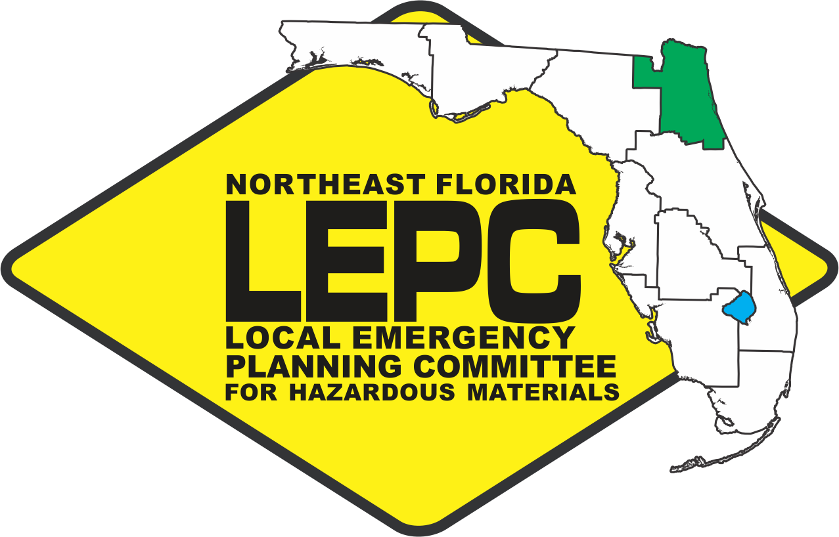 | Northeast Florida LEPC  WJCT Building  100 Festival Park Avenue  Jacksonville, Florida 32202  Wednesday, May 13, 2020  10:30a.m.

Agenda

- Call to Order

- Welcome Membership & Pledge of Allegiance

- Roll Call & Introductions

- State Emergency Response Commission (SERC) Meetings
  - Training Task Force; LEPC/Chairs; & SERC

- Current Business/Reports
  - Current LEPC actions

- Sub-Committee Reports
  - Training Report

- Presentations/ Issue Items

- Public Comments

- Adjournment* *Denotes Action

